PreProcessing using scikit-learn


Agenda
- Introduction to Preprocessing
- StandardScaler
- MinMaxScaler
- RobustScaler
- Normalization
- Binarization
- Encoding Categorical (Ordinal & Nominal) Features
- Imputation
- Polynomial Features
- Custom Transformer
- HashingVectorizer
- Image using skimage

Common import
import numpy as np
import pandas as pd
import seaborn as sns; sns.set(color_codes=True)
from mpl_toolkits.mplot3d import Axes3D
import matplotlib.pyplot as plt
%matplotlib inline

1. Introduction to PreProcessing
- Learning algorithms have affinity towards certain pattern of data.
- Unscaled or unstandardized data have might have unacceptable prediction
- Learning algorithms understands only number, converting text, image to number is required
- Preprocessing refers to transformation before feeding to machine learning
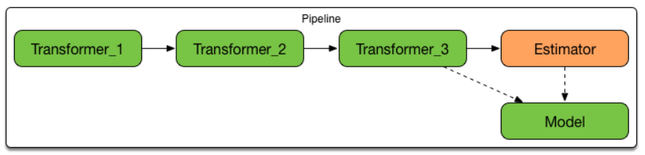

2. StandardScaler
- The StandardScaler assumes your data is normally distributed within each feature and will scale them such that the distribution is now centred around 0, with a standard deviation of 1.
- Calculate - Subtract mean of column & div by standard deviation
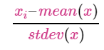
- If data is not normally distributed, this is not the best scaler to use.
#Generating normally distributed data
df = pd.DataFrame({
'x1': np.random.normal(0, 1, 10000),
'x2': np.random.normal(10, 5, 10000),
'x3': np.random.normal(50, 10, 10000)
})
df
 | x1 | x2 | x3
0 | 0.463124 | 2.365363 | 40.370022
1 | 0.122437 | 16.457868 | 45.709240
2 | -1.015430 | 12.098995 | 61.900859
3 | -0.221987 | 10.822430 | 35.914164
4 | 0.187119 | 1.450121 | 49.344819
... | ... | ... | ...
9995 | -0.358891 | 14.150942 | 52.192122
9996 | 0.423233 | 10.966956 | 58.601257
9997 | 1.174358 | 7.913014 | 43.470246
9998 | -0.513935 | 8.299045 | 39.401472
9999 | 0.124785 | 9.065921 | 45.239020
df.describe()
 | x1 | x2 | x3
count | 10000.000000 | 10000.000000 | 10000.000000
mean | -0.004755 | 9.976345 | 49.984226
std | 0.996212 | 4.971475 | 9.993464
min | -3.600523 | -8.676614 | 13.567828
25% | -0.666085 | 6.607681 | 43.277881
50% | 0.000930 | 9.972108 | 49.988434
75% | 0.661591 | 13.360785 | 56.922647
max | 3.770515 | 26.871835 | 88.228439
# plotting data
df.plot.kde()
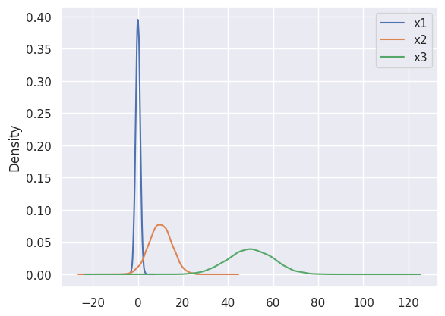
from sklearn.preprocessing import StandardScaler
standardscaler = StandardScaler()
data_tf = standardscaler.fit_transform(df)
type(data_tf)
numpy.ndarray
df = pd.DataFrame(data_tf, columns=['x1','x2','x3'])
df
 | x1 | x2 | x3
0 | 0.469682 | -1.531007 | -0.962097
1 | 0.127682 | 1.303808 | -0.427800
2 | -1.014569 | 0.426987 | 1.192502
3 | -0.218069 | 0.170196 | -1.407997
4 | 0.192613 | -1.715115 | -0.063986
... | ... | ... | ...
9995 | -0.355500 | 0.839752 | 0.220945
9996 | 0.429637 | 0.199269 | 0.862310
9997 | 1.183655 | -0.415055 | -0.651857
9998 | -0.511142 | -0.337402 | -1.059020
9999 | 0.130039 | -0.183139 | -0.474855
df.describe()
 | x1 | x2 | x3
count | 1.000000e+04 | 1.000000e+04 | 1.000000e+04
mean | 3.552714e-18 | 1.101341e-16 | 2.987832e-16
std | 1.000050e+00 | 1.000050e+00 | 1.000050e+00
min | -3.609620e+00 | -3.752185e+00 | -3.644204e+00
25% | -6.638779e-01 | -6.776325e-01 | -6.711066e-01
50% | 5.706764e-03 | -8.522445e-04 | 4.211805e-04
75% | 6.689133e-01 | 6.808058e-01 | 6.943306e-01
max | 3.789813e+00 | 3.398657e+00 | 3.827114e+00
df.plot.kde()
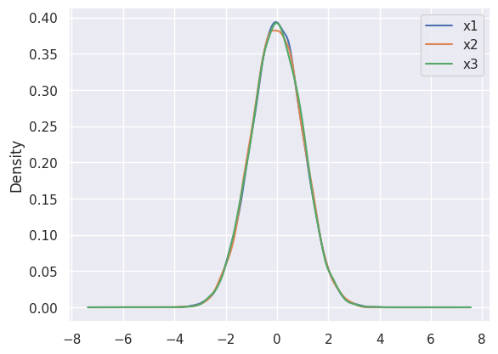

3. MinMaxScaler
- One of the most popular
- Calculate - Subtract min of column & div by difference between max & min
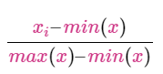
- Data shifts between 0 & 1
- If distribution not suitable for StandardScaler, this scaler works out.
- Sensitive to outliers
df = pd.DataFrame({
# positive skew
'x1': np.random.chisquare(8, 1000),
# negative skew
'x2': np.random.beta(8, 2, 1000) * 40,
# no skew
'x3': np.random.normal(50, 3, 1000)
})
df.plot.kde()
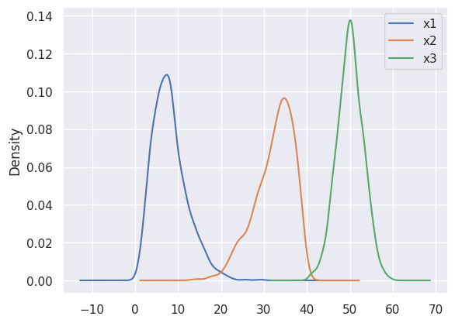
from sklearn.preprocessing import MinMaxScaler
minmax = MinMaxScaler()
data_tf = minmax.fit_transform(df)
df = pd.DataFrame(data_tf,columns=['x1','x2','x3'])
df.plot.kde()
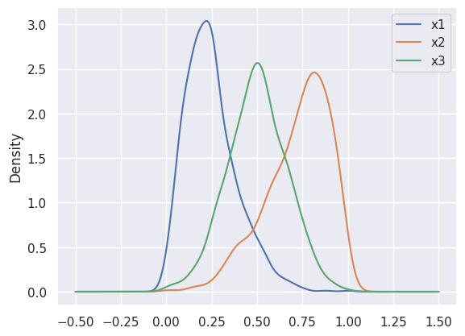

4. Robust Scaler
- Suited for data with outliers
- Calculate by subtracting 1st-quartile & div by difference between 3rd-quartile & 1st-quartile
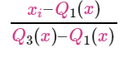
df = pd.DataFrame({
# Distribution with lower outliers
'x1': np.concatenate([np.random.normal(20, 1, 1000), np.random.normal(1, 1, 25)]),
# Distribution with higher outliers
'x2': np.concatenate([np.random.chisquare(15, 1000), np.random.normal(50, 1, 25)]),
})
df.plot.kde()
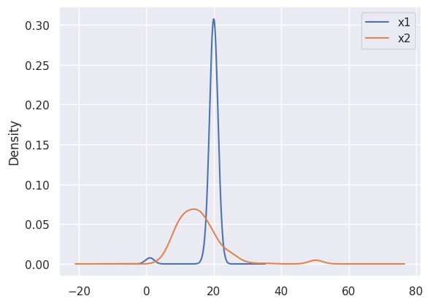
from sklearn.preprocessing import RobustScaler
robustscaler = RobustScaler()
data_tf = robustscaler.fit_transform(df)
df = pd.DataFrame(data_tf, columns=['x1','x2'])
df
 | x1 | x2
0 | 1.074620 | 0.969802
1 | 1.169918 | -1.108542
2 | -0.542149 | 0.139105
3 | -0.442237 | -0.656917
4 | 0.166445 | 0.536792
... | ... | ...
1020 | -13.563157 | 4.514469
1021 | -13.570401 | 4.792702
1022 | -13.343961 | 4.756797
1023 | -13.516608 | 4.727187
1024 | -13.068275 | 4.640128
df.describe()
 | x1 | x2
count | 1025.000000 | 1025.000000
mean | -0.314049 | 0.133781
std | 2.211162 | 0.991235
min | -14.825119 | -1.496884
25% | -0.487669 | -0.490086
50% | 0.000000 | 0.000000
75% | 0.512331 | 0.509914
max | 2.318372 | 4.905623
df.plot.kde()
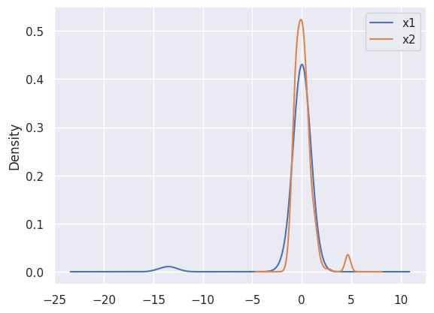

5. Normalizer
- Each parameter value is obtained by dividing by magnitude
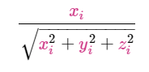
- Centralizes data to origin
df = pd.DataFrame({
'x1': np.random.randint(-100, 100, 1000).astype(float),
'y1': np.random.randint(-20, 80, 1000).astype(float),
'z1': np.random.randint(-50, 150, 1000).astype(float),
})
fig = plt.figure()
ax = plt.axes(projection='3d')
ax.scatter3D(df.x1, df.y1, df.z1)
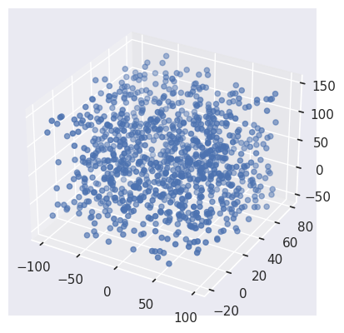
from sklearn.preprocessing import Normalizer
normalizer = Normalizer()
data_tf = normalizer.fit_transform(df)
df = pd.DataFrame(data_tf, columns=['x1','y1','z1'])
ax = plt.axes(projection='3d')
ax.scatter3D(df.x1, df.y1, df.z1)
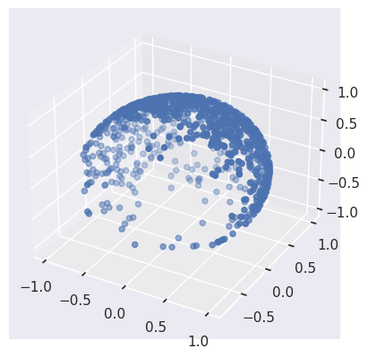

6. Binarization
- Thresholding numerical values to binary values ( 0 or 1 )
- A few learning algorithms assume data to be in Bernoulli distribution - Bernoulli's Naive Bayes
X = np.array([[ 1., -1., 2.],
[ 2., 0., 0.],
[ 0., 1., -1.]])
from sklearn.preprocessing import Binarizer
binarizer = Binarizer(threshold=1.0)
data_tf = binarizer.fit_transform(X)
data_tf
array([[0., 0., 1.],
[1., 0., 0.],
[0., 0., 0.]])

7. Encoding Categorical Values

Encoding Ordinal Values
- Ordinal Values - Low, Medium & High. Relationship between values
- LabelEncoding with right mapping
df = pd.DataFrame({
'Age':[33,44,22,44,55,22],
'Income':['Low','Low','High','Medium','Medium','High']})
df
 | Age | Income
0 | 33 | Low
1 | 44 | Low
2 | 22 | High
3 | 44 | Medium
4 | 55 | Medium
5 | 22 | High
df.Income.map({'Low':1,'Medium':2,'High':3})
 | Income
0 | 1
1 | 1
2 | 3
3 | 2
4 | 2
5 | 3

PS: We can use transformer class for this as well, we will see that later

Encoding Nominal Values
- Nominal Values - Male, Female. No relationship between data
- One Hot Encoding for converting data into one-hot vector
df = pd.DataFrame({
'Age':[33,44,22,44,55,22,35],
'Gender':['Male','Female','Male','Female','Male','Male','LGBTQ']})
df.Gender.unique()
array(['Male', 'Female', 'LGBTQ'], dtype=object)
print(pd.get_dummies(df.Gender))
Female LGBTQ Male
0 False False True
1 True False False
2 False False True
3 True False False
4 False False True
5 False False True
6 False True False
from sklearn.preprocessing import LabelEncoder,OneHotEncoder
le = LabelEncoder()
df['gender_tf'] = le.fit_transform(df.Gender)
df
 | Age | Gender | gender_tf
0 | 33 | Male | 2
1 | 44 | Female | 0
2 | 22 | Male | 2
3 | 44 | Female | 0
4 | 55 | Male | 2
5 | 22 | Male | 2
6 | 35 | LGBTQ | 1
OneHotEncoder().fit_transform(df[['gender_tf']]).toarray()
array([[0., 0., 1.],
[1., 0., 0.],
[0., 0., 1.],
[1., 0., 0.],
[0., 0., 1.],
[0., 0., 1.],
[0., 1., 0.]])
df = pd.DataFrame({
'Age':[33,44,22,44,55,22],
'Income':['Low','Low','High','Medium','Medium','High']})
df['Income_label'] = le.fit_transform(df.Income)
df
 | Age | Income | Income_label
0 | 33 | Low | 1
1 | 44 | Low | 1
2 | 22 | High | 0
3 | 44 | Medium | 2
4 | 55 | Medium | 2
5 | 22 | High | 0

8. Imputation
- Missing values cannot be processed by learning algorithms
- Imputers can be used to infer value of missing data from existing data
df = pd.DataFrame({
'A':[1,2,3,4,np.nan,7],
'B':[3,4,10,np.nan,4,5]
})
from sklearn.impute import SimpleImputer
imputer = SimpleImputer(strategy='mean')
df_copy = imputer.fit_transform(df)
df_copy
array([[ 1. , 3. ],
[ 2. , 4. ],
[ 3. , 10. ],
[ 4. , 5.2],
[ 3.4, 4. ],
[ 7. , 5. ]])

9. Polynomial Features
- Deriving non-linear feature by coverting data into higher degree
- Used with linear regression to learn model of higher degree
df = pd.DataFrame({'A':[1,2,3,4,5], 'B':[2,3,4,5,6]})
df
 | A | B
0 | 1 | 2
1 | 2 | 3
2 | 3 | 4
3 | 4 | 5
4 | 5 | 6
from sklearn.preprocessing import PolynomialFeatures
pol = PolynomialFeatures(degree=2, include_bias=True)
pol.fit_transform(df)
array([[ 1., 1., 2., 1., 2., 4.],
[ 1., 2., 3., 4., 6., 9.],
[ 1., 3., 4., 9., 12., 16.],
[ 1., 4., 5., 16., 20., 25.],
[ 1., 5., 6., 25., 30., 36.]])

10. Custom Transformer
- Often, you will want to convert an existing Python function into a transformer to assist in data cleaning or processing.
- FunctionTransformer is used to create one Transformer
- validate = False, is required for string columns
from sklearn.preprocessing import FunctionTransformer
def mapping(x):
x['Age'] = x['Age']+2
x['Counter'] = x['Counter'] * 2
return x
customtransformer = FunctionTransformer(mapping, validate=False)
df = pd.DataFrame({
'Age':[33,44,22,44,55,22],
'Counter':[3,4,2,4,5,2],
})
df
 | Age | Counter
0 | 33 | 3
1 | 44 | 4
2 | 22 | 2
3 | 44 | 4
4 | 55 | 5
5 | 22 | 2
customtransformer.transform(df)
 | Age | Counter
0 | 35 | 6
1 | 46 | 8
2 | 24 | 4
3 | 46 | 8
4 | 57 | 10
5 | 24 | 4
print (type(customtransformer))
<class 'sklearn.preprocessing._function_transformer.FunctionTransformer'>

11. HashingVectorizer
- All above techniques converts data into table where each word is converted to column
- Learning on data with lakhs of columns is difficult to process
- HashingVectorizer is an useful technique for out-of-core learning
- Multiple words are hashed to limited column
- Limitation - Hashed value to word mapping is not possible
df = pd.DataFrame({
'A':[1,2,3,4,np.nan,7],
'B':[3,4,1,np.nan,4,5],
'Text':['I','am','going','the','opposite','way']
})
from sklearn.feature_extraction.text import HashingVectorizer
hv = HashingVectorizer(n_features=5)
hv.fit_transform(df.Text).toarray()
array([[ 0., 0., 0., 0., 0.],
[ 1., 0., 0., 0., 0.],
[ 0., 0., 0., 0., -1.],
[ 0., 0., 0., -1., 0.],
[ 0., -1., 0., 0., 0.],
[ 0., 0., 0., 0., 1.]])

12. Image Processing using skimage
- skimage doesn't come with anaconda. install with 'pip install skimage'
- Images should be converted from 0-255 scale to 0-1 scale.
- skimage takes image path & returns numpy array
- images consist of 3 dimension
! pip install scikit-image
Requirement already satisfied: scikit-image in /usr/local/lib/python3.12/dist-packages (0.25.2)
Requirement already satisfied: numpy>=1.24 in /usr/local/lib/python3.12/dist-packages (from scikit-image) (2.0.2)
Requirement already satisfied: scipy>=1.11.4 in /usr/local/lib/python3.12/dist-packages (from scikit-image) (1.16.3)
Requirement already satisfied: networkx>=3.0 in /usr/local/lib/python3.12/dist-packages (from scikit-image) (3.5)
Requirement already satisfied: pillow>=10.1 in /usr/local/lib/python3.12/dist-packages (from scikit-image) (11.3.0)
Requirement already satisfied: imageio!=2.35.0,>=2.33 in /usr/local/lib/python3.12/dist-packages (from scikit-image) (2.37.2)
Requirement already satisfied: tifffile>=2022.8.12 in /usr/local/lib/python3.12/dist-packages (from scikit-image) (2025.10.16)
Requirement already satisfied: packaging>=21 in /usr/local/lib/python3.12/dist-packages (from scikit-image) (25.0)
Requirement already satisfied: lazy-loader>=0.4 in /usr/local/lib/python3.12/dist-packages (from scikit-image) (0.4)
from skimage.io import imread,imshow
image = imread('/content/dog.jpg')
image.shape
(430, 710, 3)
image
ndarray (430, 710, 3) show data
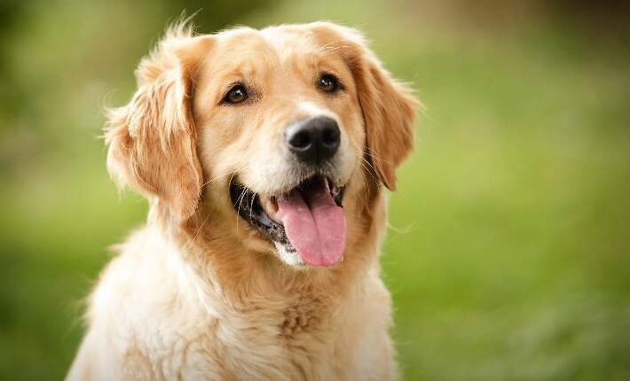
array([[[56, 64, 17],
[56, 64, 17],
[55, 63, 16],
...,
[43, 35, 14],
[43, 35, 14],
[43, 35, 14]],
[[55, 63, 16],
[55, 63, 16],
[55, 63, 16],
...,
[43, 35, 14],
[43, 35, 14],
[43, 35, 14]],
[[54, 62, 15],
[54, 62, 15],
[54, 62, 15],
...,
[43, 35, 14],
[43, 35, 14],
[43, 35, 14]],
...,
[[64, 76, 12],
[64, 76, 12],
[65, 77, 13],
...,
[79, 89, 37],
[79, 89, 37],
[78, 88, 36]],
[[63, 75, 11],
[64, 76, 12],
[64, 76, 12],
...,
[79, 89, 37],
[78, 88, 36],
[78, 88, 36]],
[[63, 75, 11],
[63, 75, 11],
[64, 76, 12],
...,
[78, 88, 36],
[78, 88, 36],
[77, 87, 35]]], dtype=uint8)
image[0]
array([[56, 64, 17],
[56, 64, 17],
[55, 63, 16],
...,
[43, 35, 14],
[43, 35, 14],
[43, 35, 14]], dtype=uint8)
imshow(image)
/tmp/ipython-input-3355601266.py:1: FutureWarning: `imshow` is deprecated since version 0.25 and will be removed in version 0.27. Please use `matplotlib`, `napari`, etc. to visualize images.
imshow(image)
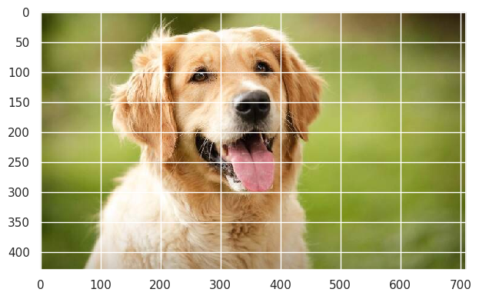
from skimage.color import rgb2gray
rgb2gray(image).shape
(430, 710)
print(rgb2gray(image))
[[0.23102471 0.23102471 0.22710314 ... 0.13798392 0.13798392 0.13798392]
[0.22710314 0.22710314 0.22710314 ... 0.13798392 0.13798392 0.13798392]
[0.22318157 0.22318157 0.22318157 ... 0.13798392 0.13798392 0.13798392]
...
[0.26994353 0.26994353 0.2738651 ... 0.32598353 0.32598353 0.32206196]
[0.26602196 0.26994353 0.26994353 ... 0.32598353 0.32206196 0.32206196]
[0.26602196 0.26602196 0.26994353 ... 0.32206196 0.32206196 0.31814039]]
rgb_image = rgb2gray(image)
rgb_image
array([[0.23102471, 0.23102471, 0.22710314, ..., 0.13798392, 0.13798392,
0.13798392],
[0.22710314, 0.22710314, 0.22710314, ..., 0.13798392, 0.13798392,
0.13798392],
[0.22318157, 0.22318157, 0.22318157, ..., 0.13798392, 0.13798392,
0.13798392],
...,
[0.26994353, 0.26994353, 0.2738651 , ..., 0.32598353, 0.32598353,
0.32206196],
[0.26602196, 0.26994353, 0.26994353, ..., 0.32598353, 0.32206196,
0.32206196],
[0.26602196, 0.26602196, 0.26994353, ..., 0.32206196, 0.32206196,
0.31814039]])
rgb_image[200:300]= 0
imshow(rgb_image)
/tmp/ipython-input-349728104.py:1: FutureWarning: `imshow` is deprecated since version 0.25 and will be removed in version 0.27. Please use `matplotlib`, `napari`, etc. to visualize images.
imshow(rgb_image)
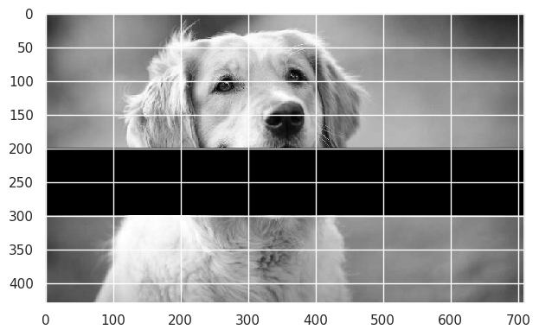
from skimage.transform import resize
imshow(resize(image, (150,200)))
/tmp/ipython-input-4182925553.py:1: FutureWarning: `imshow` is deprecated since version 0.25 and will be removed in version 0.27. Please use `matplotlib`, `napari`, etc. to visualize images.
imshow(resize(image, (150,200)))
